- Launch one EC2 using Amazon Linux 2 image and add a script in user data to install Apache.
While creating instance, I just added script to install apache (web server) in user data and I launched the instance.
I connected my EC2 instance into local, I just checked with status command for apache server is running or not.
It’s installed and running
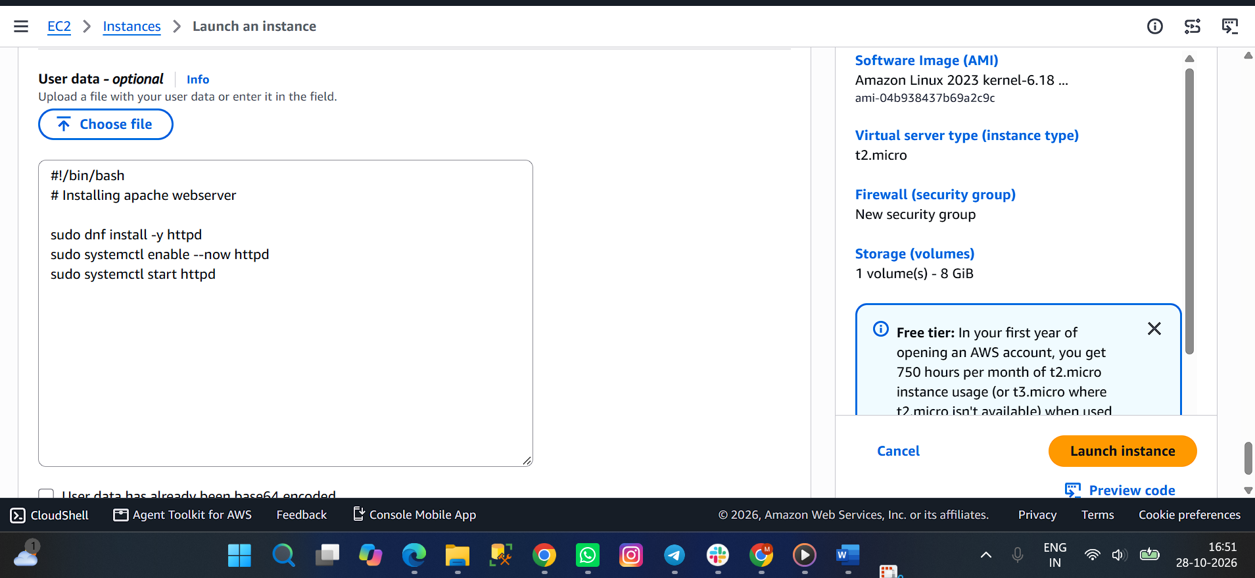
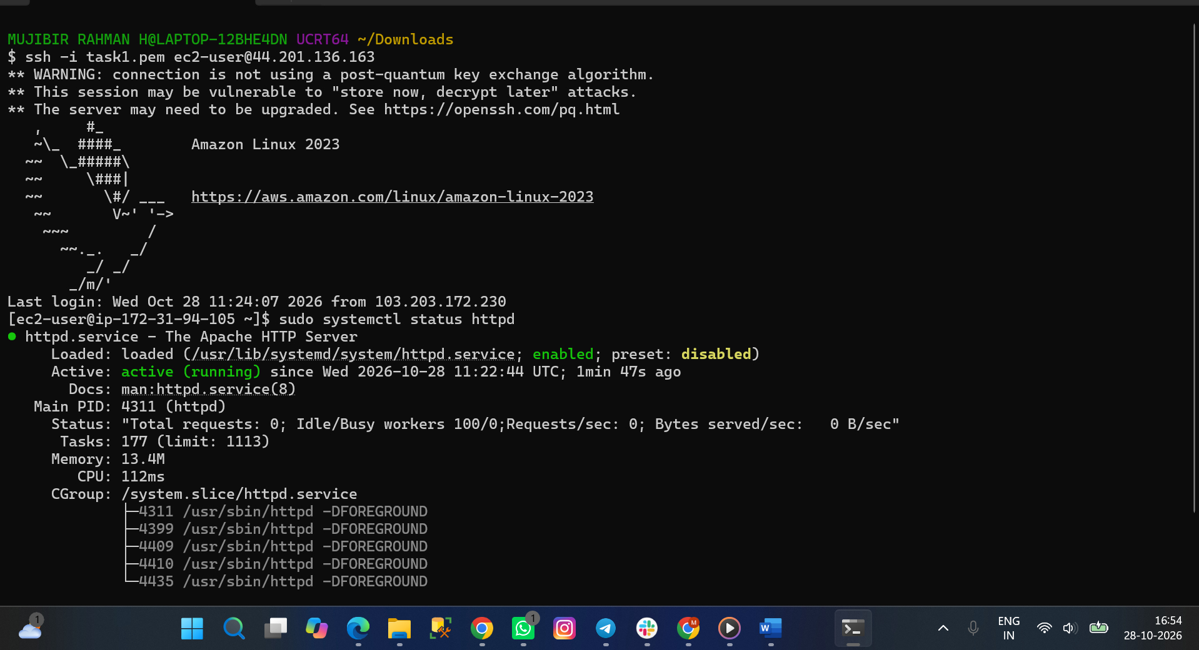
- Launch one EC2 using Ubuntu image and add a script in user data to install Nginx.
Instead of Amazon Linux, I just selected ubuntu AMI and written the script for installing nginx.
After that, I connected ubuntu to local- I just checked the status of nginx. It’s running.
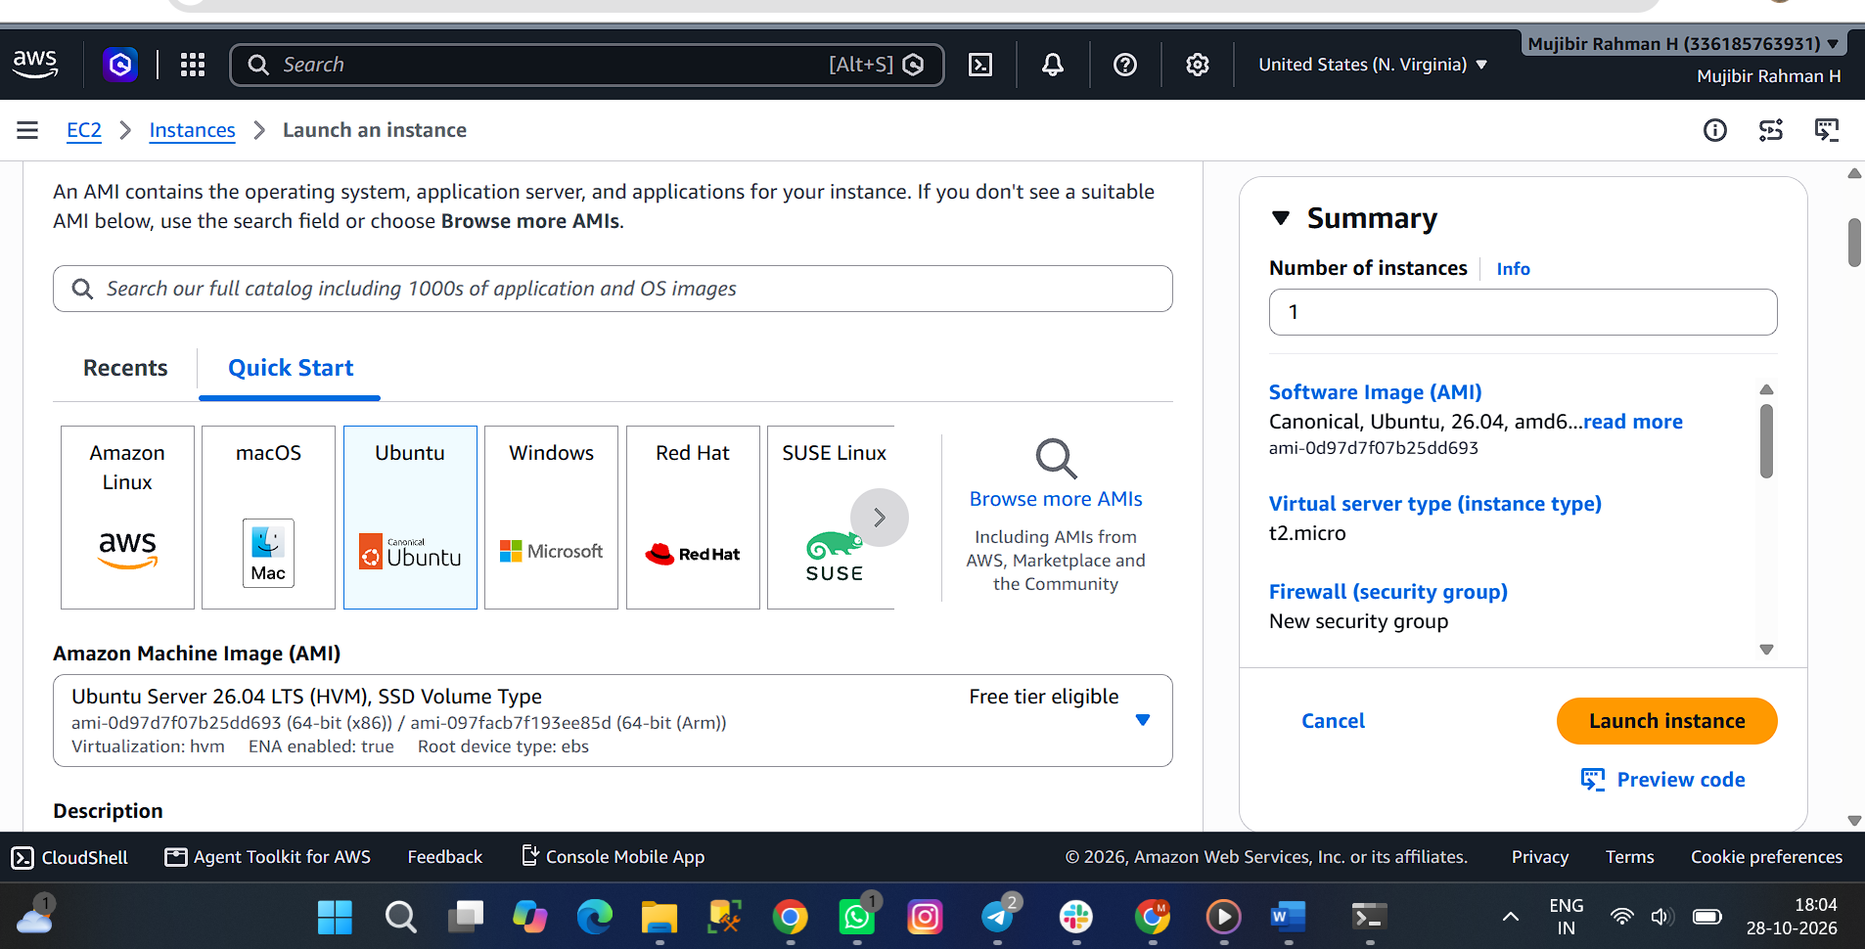
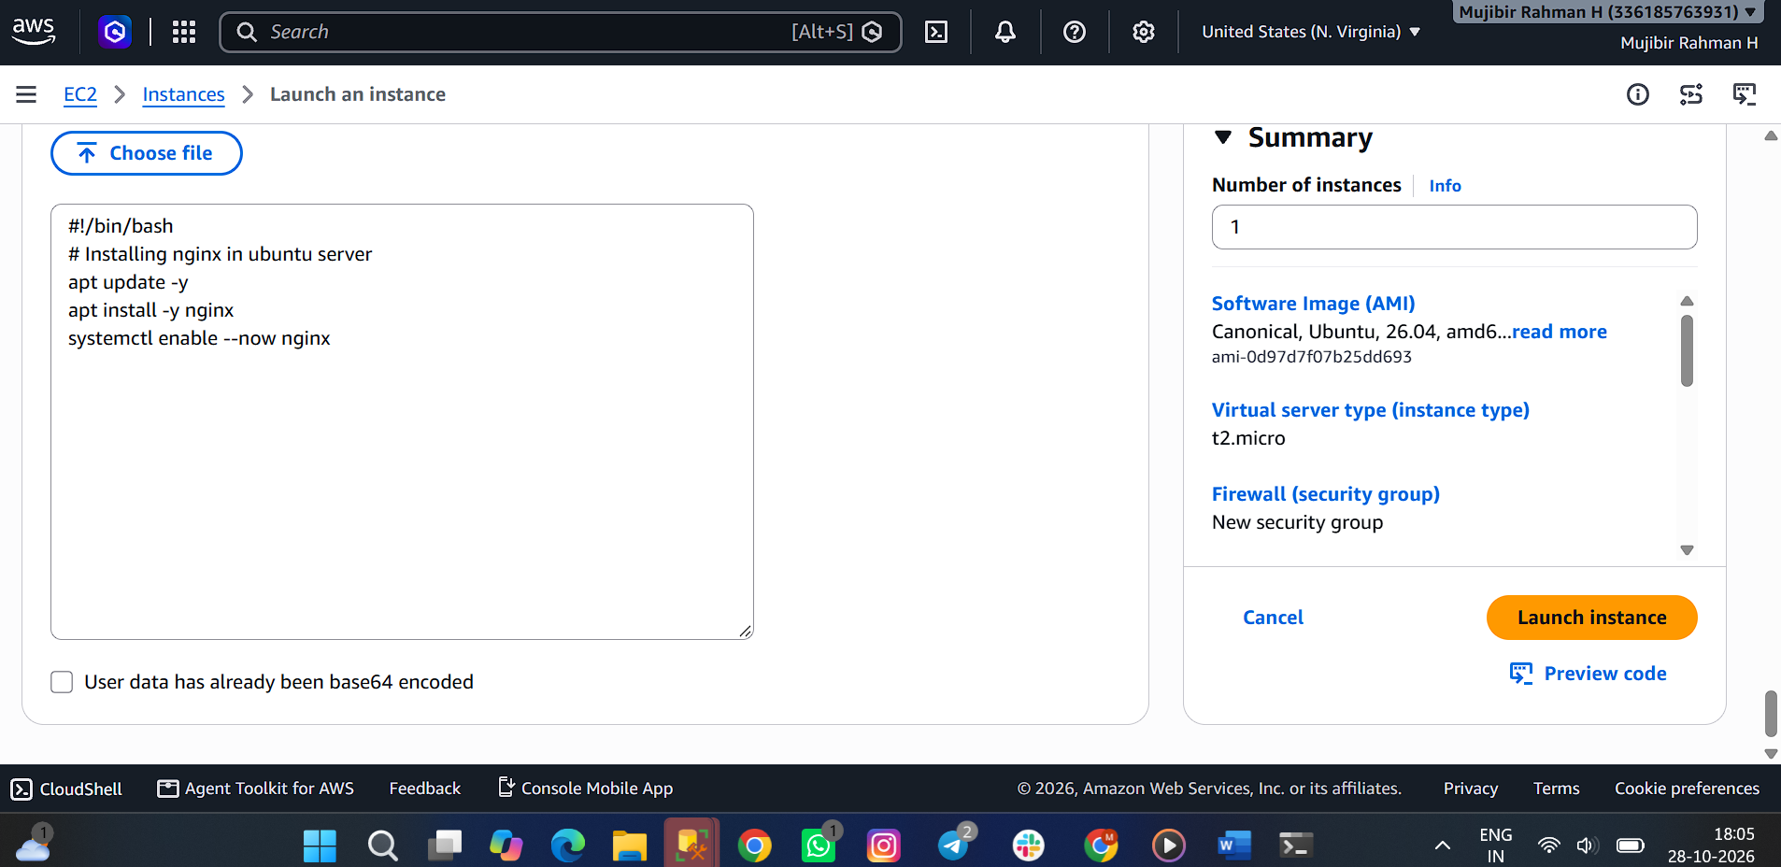
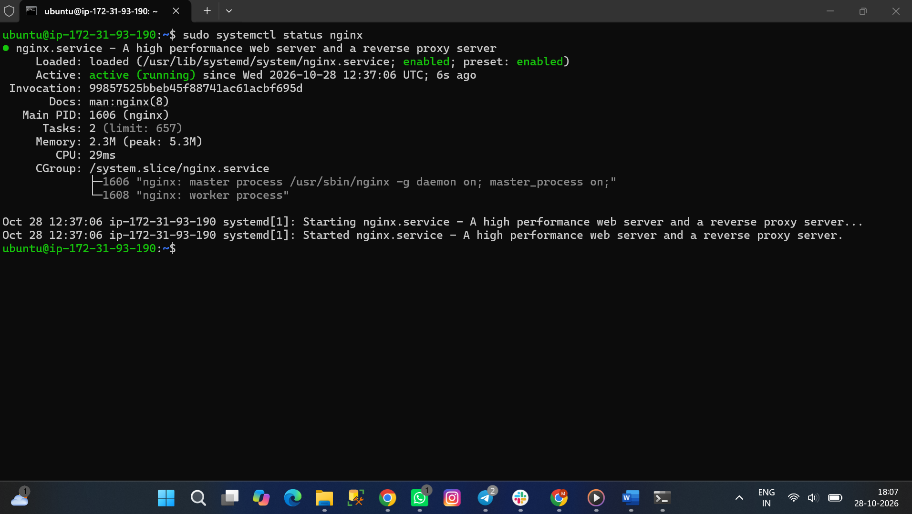
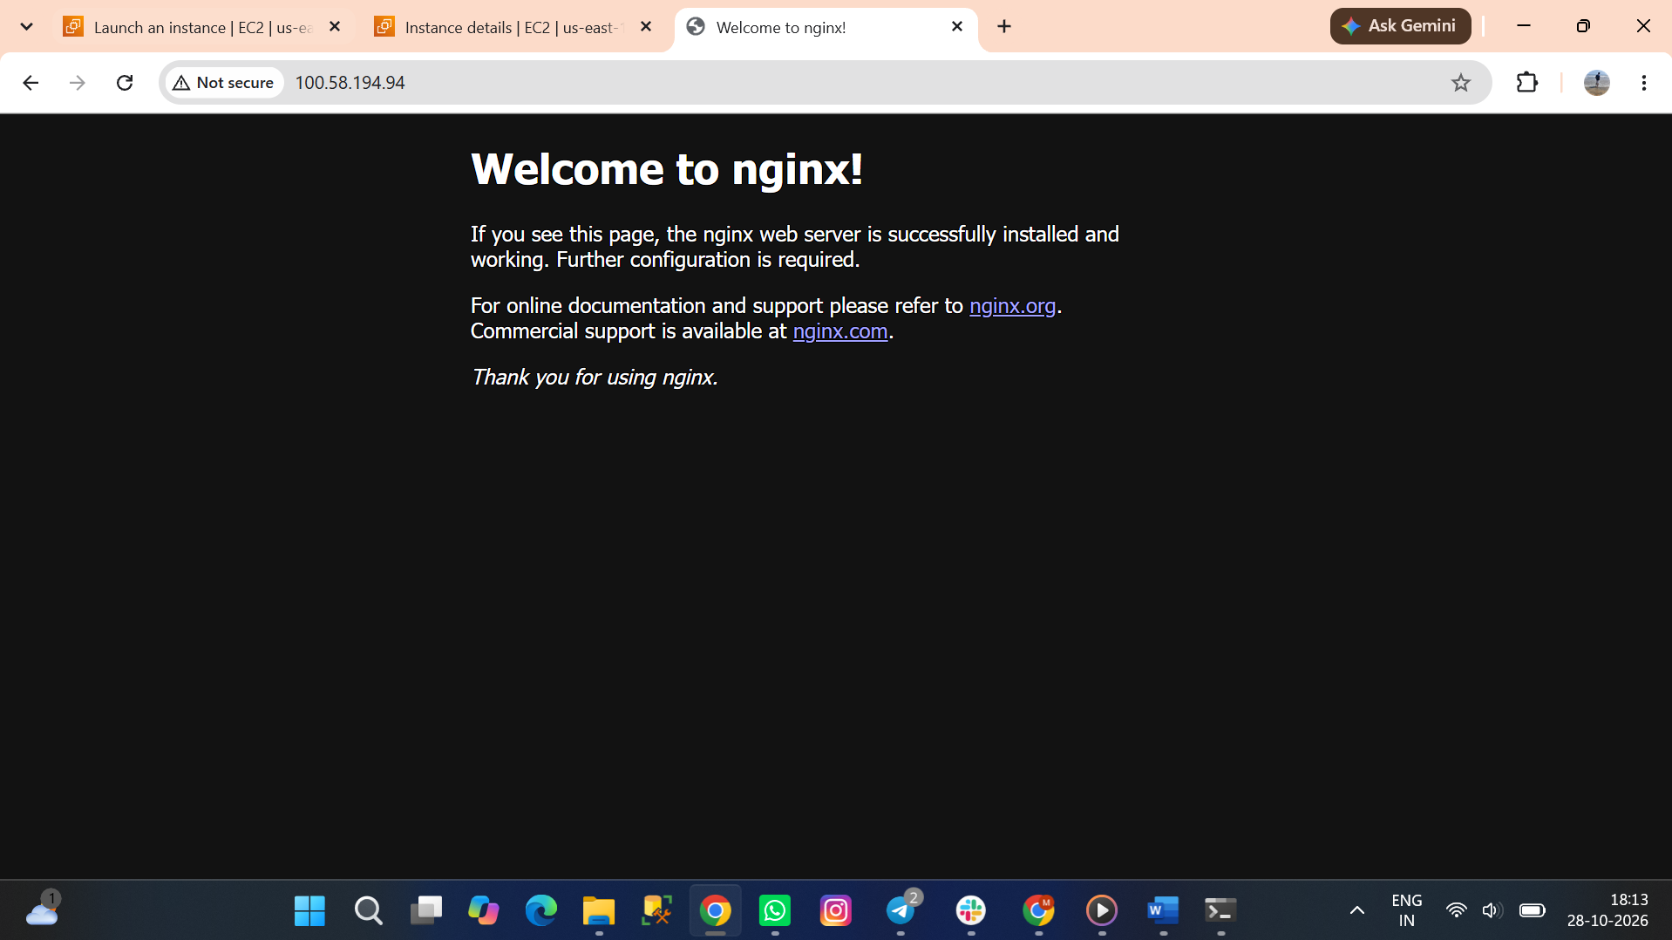
- Launch one Windows server and install Tomcat on Windows.
Usually, will try to use linux or ubuntu AMI for providion of EC2 server.
Instead of I used windows server 2022 AMI .
In security RDP port enabled automatically, If not, We need to enable that.
Now, Instance is created. I want to connect that windows server to local
I opened the instance and click connect icon. We are able to see connect Remote Desktop protocol. Navigate to that.
We need to open remote desktop in our local – We need to paste our Public DNS in computer field -Username- Password (Using get password, nothing we need to paste our pem.key content in box will get one line password)
Now, we are able to connect the windows server to local.
I installed tomcat manually(In browser) in windows server after the installation of JDK.
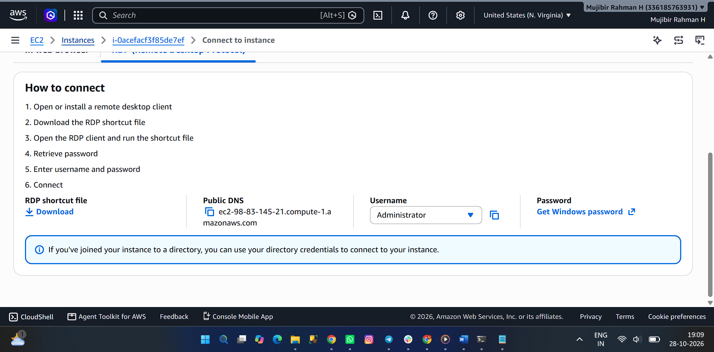
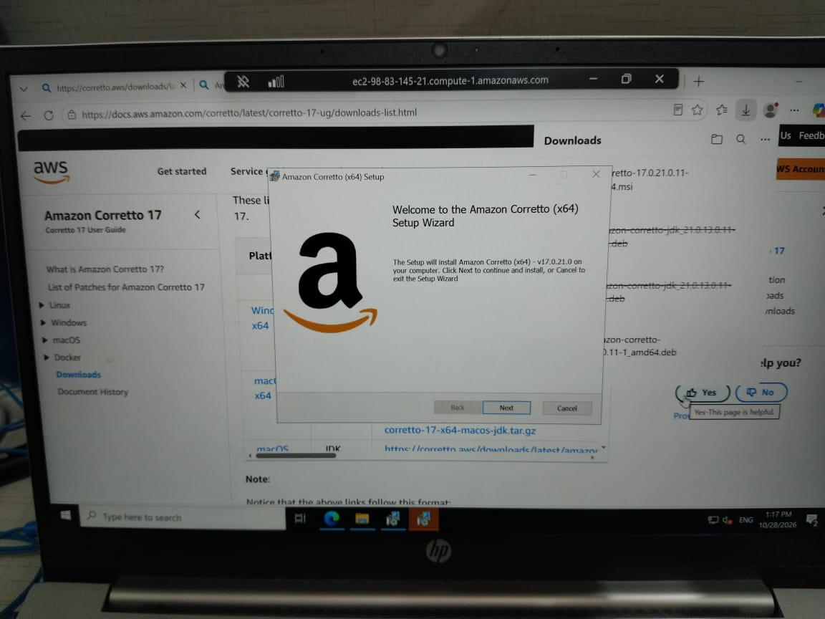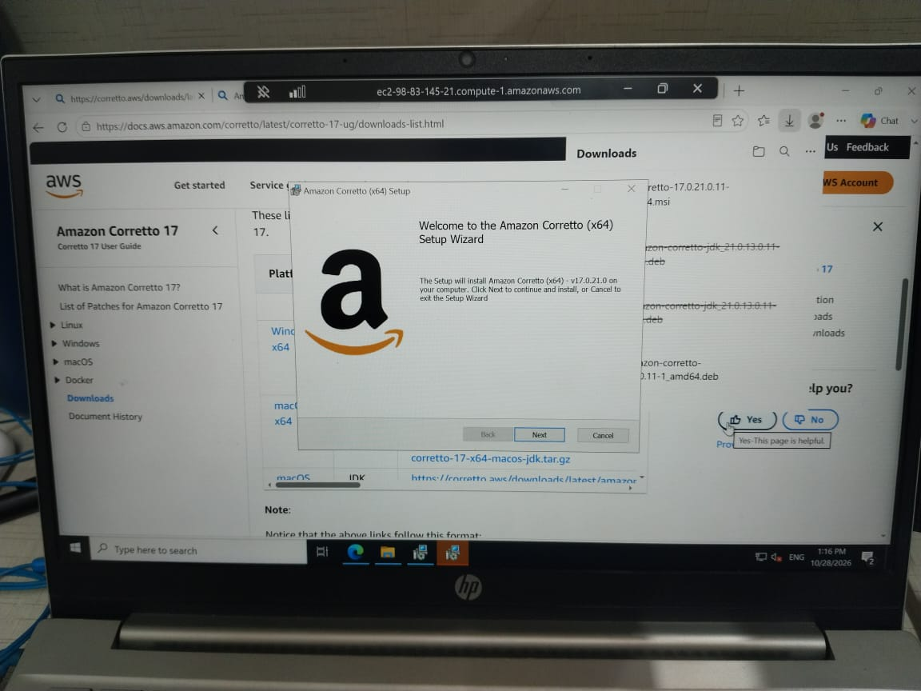
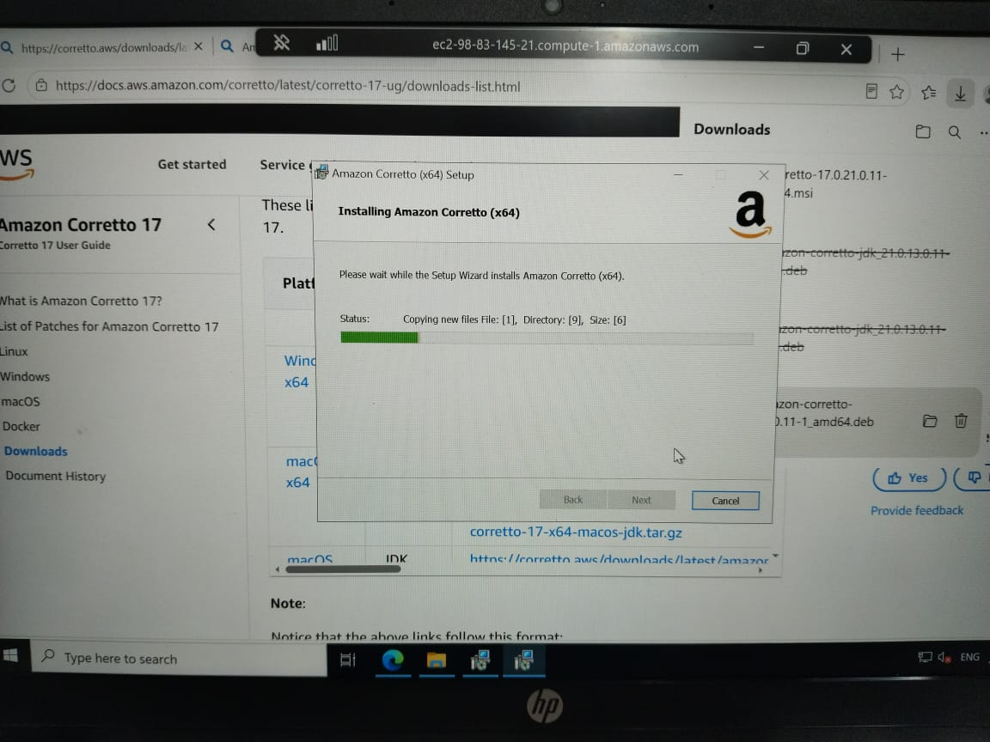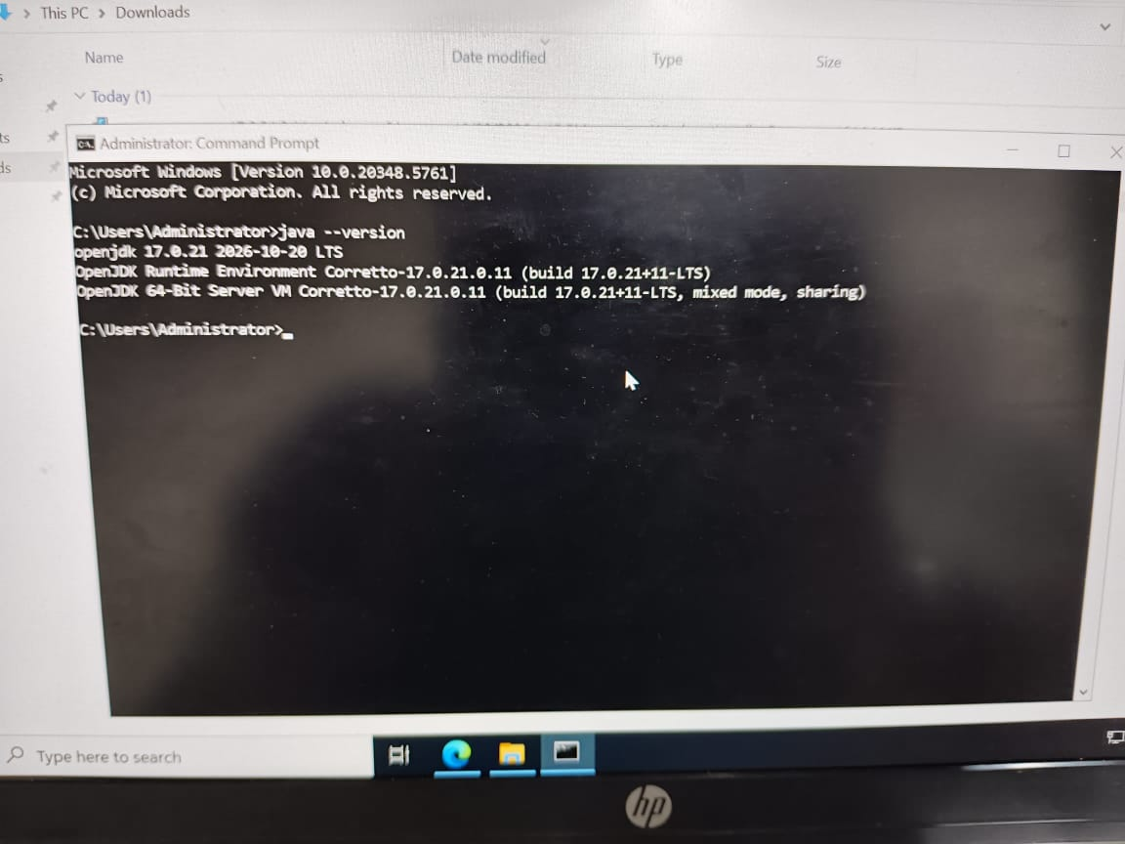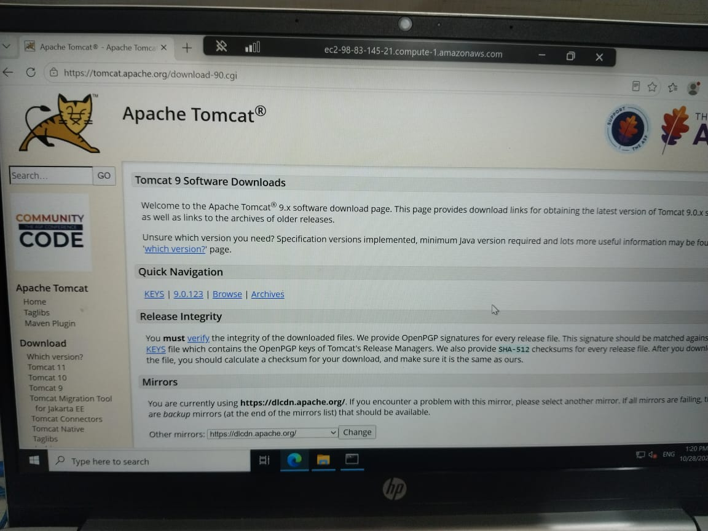
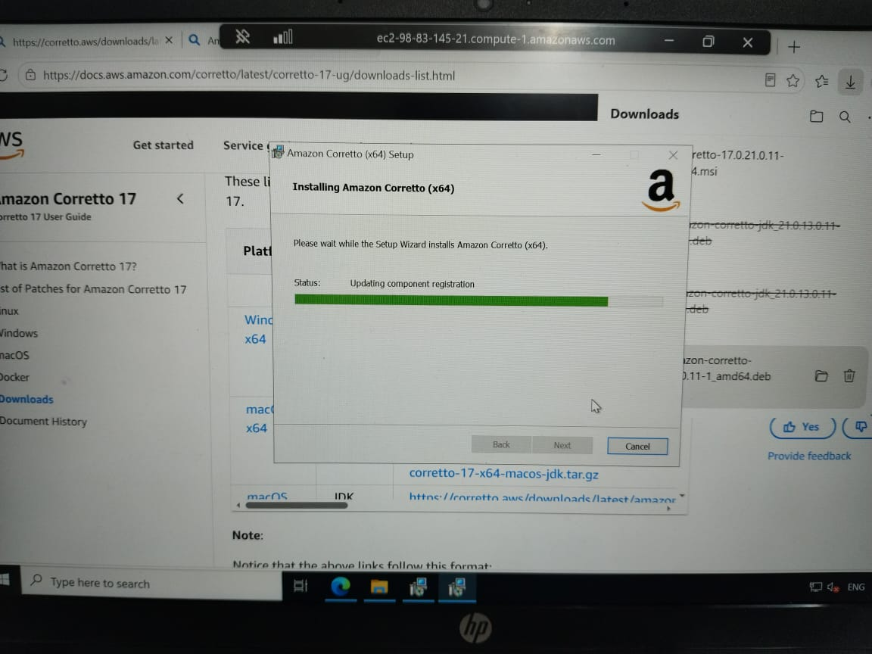
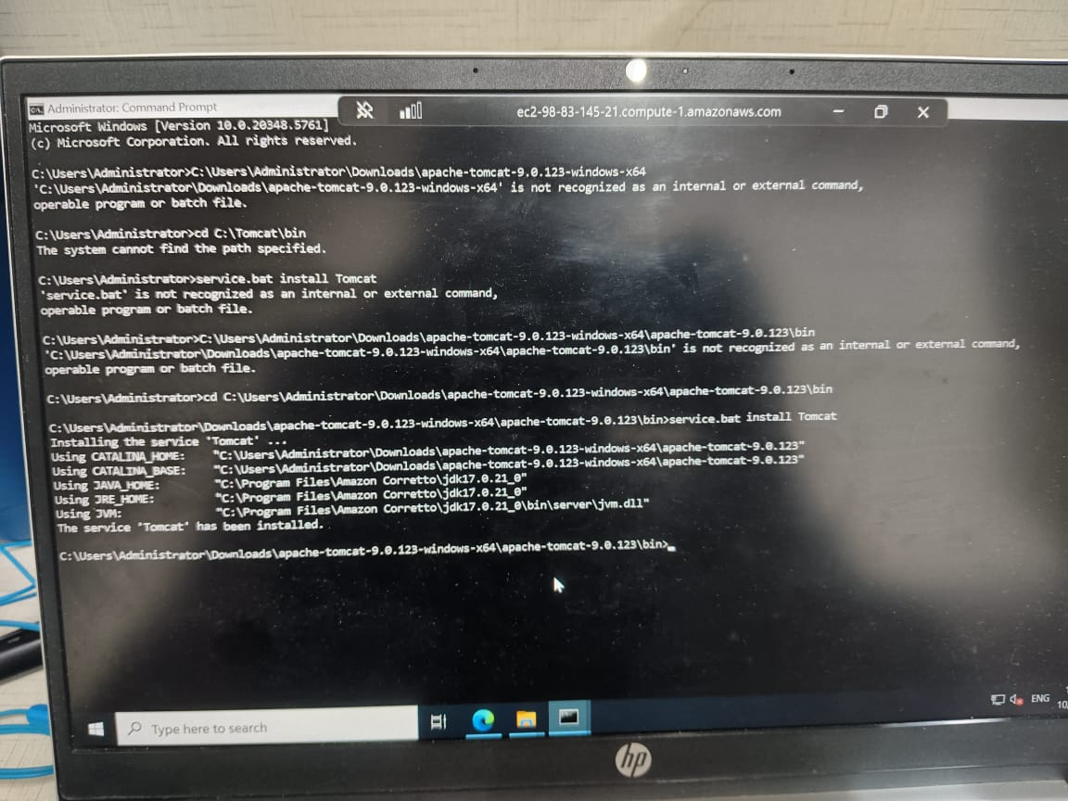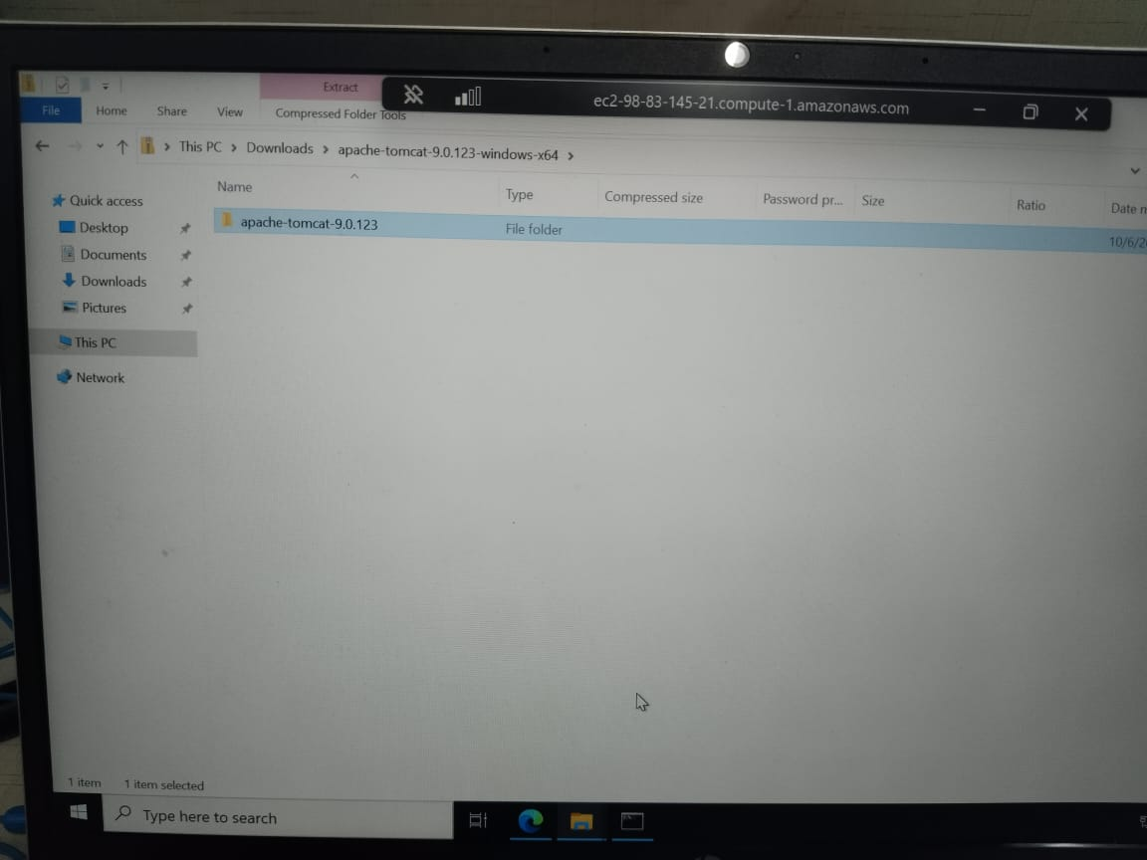
- Take a snapshot of the instance created in Task 1.
Period of time taking the copy of ebs.
This will help to recover the instance. (If pem.key is lost, we are not able to connect to instance that time this backup will help to connect)
Settings – storage – volume -snapshot
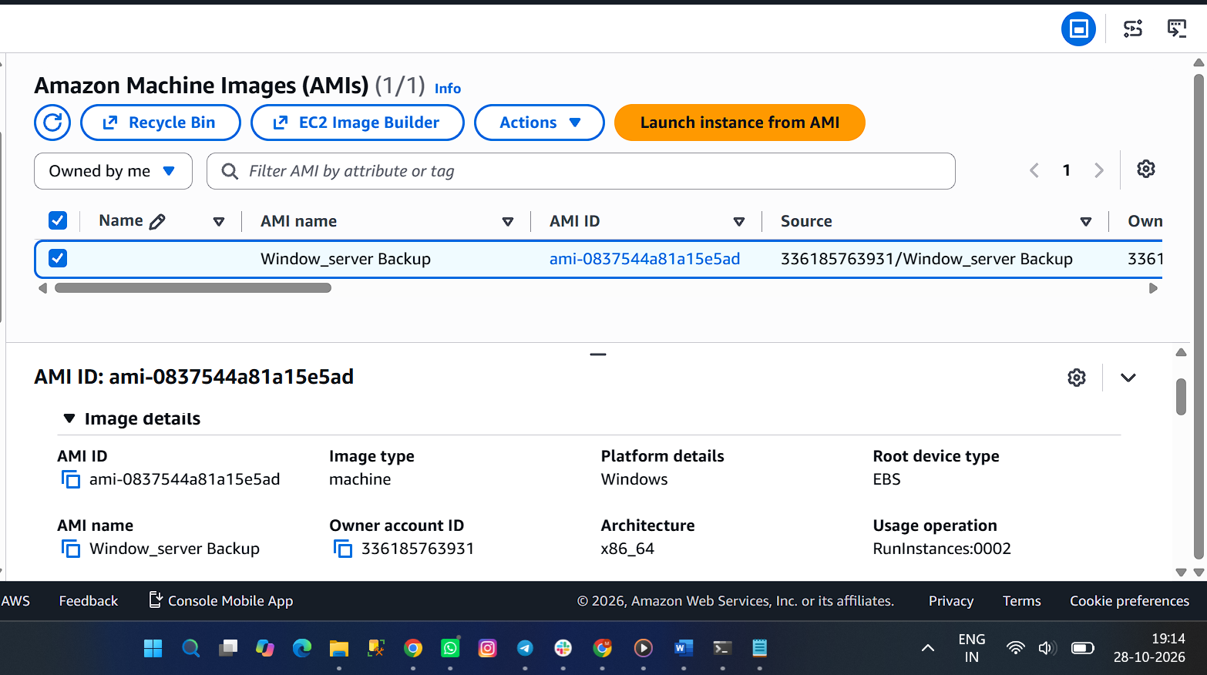
Or
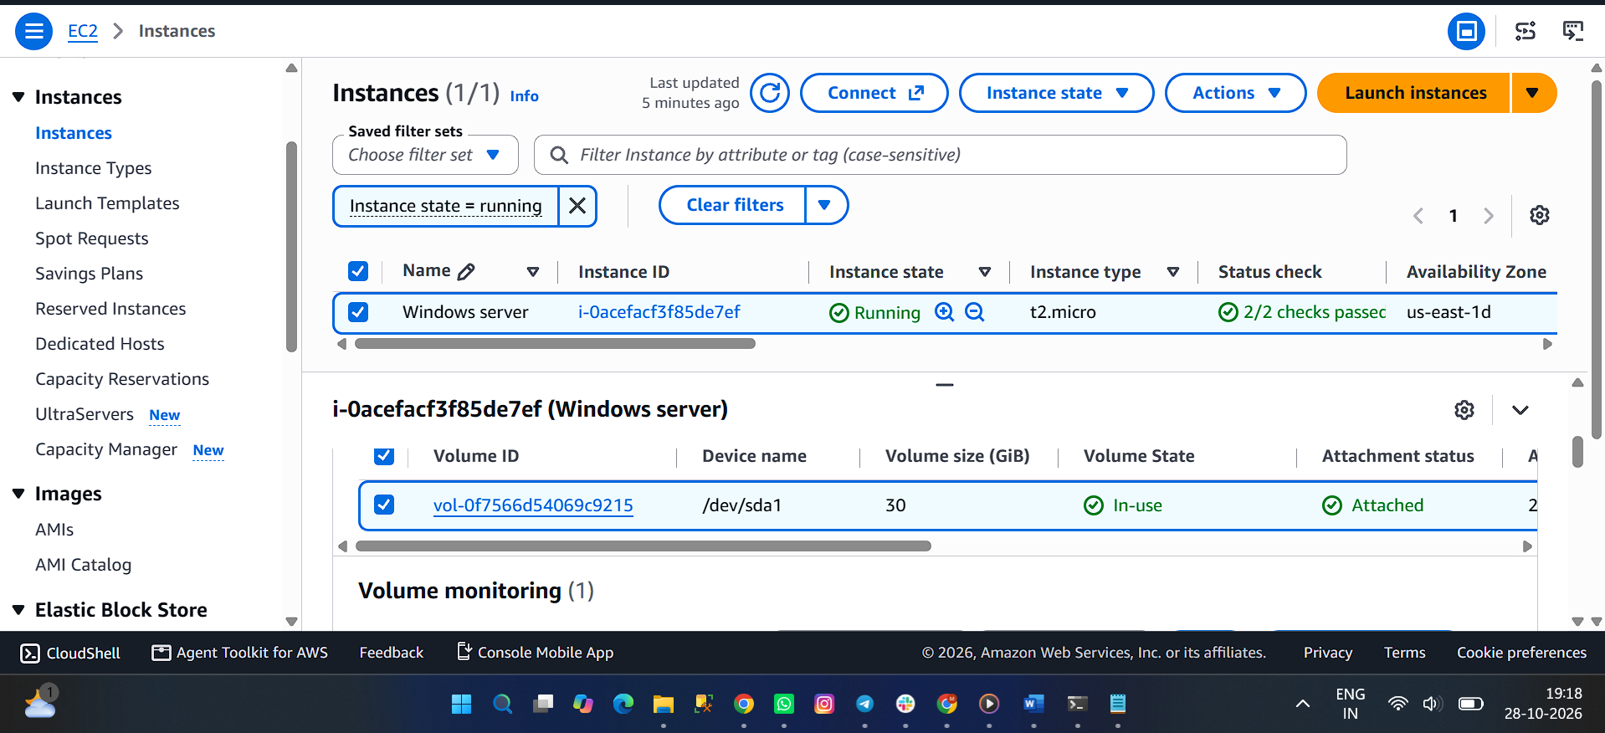
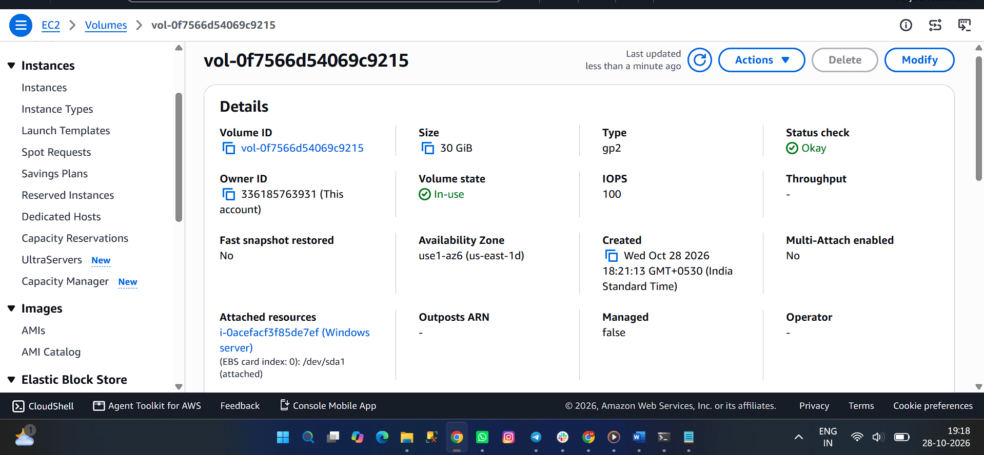
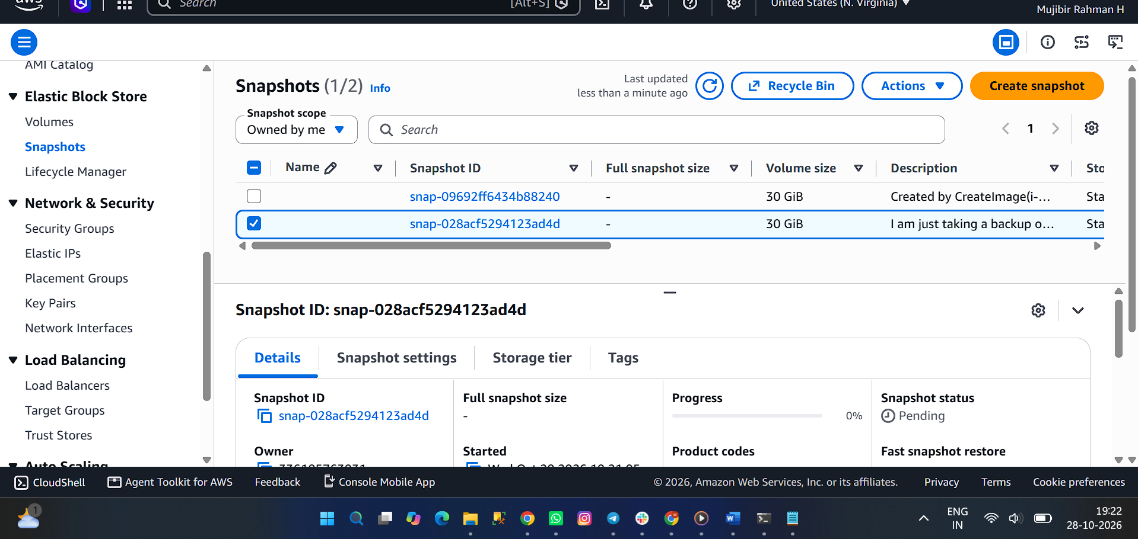
- Assign passwordless authentication for the EC2 created in Task 2.
I already having a keygen in my local desktop. (If not just generate that using ssh-keygen )
Just copy this and paste it in ec2 server hidden file (~/.ssh – authorized key )
Try to login again without pem.key to the server, it will work
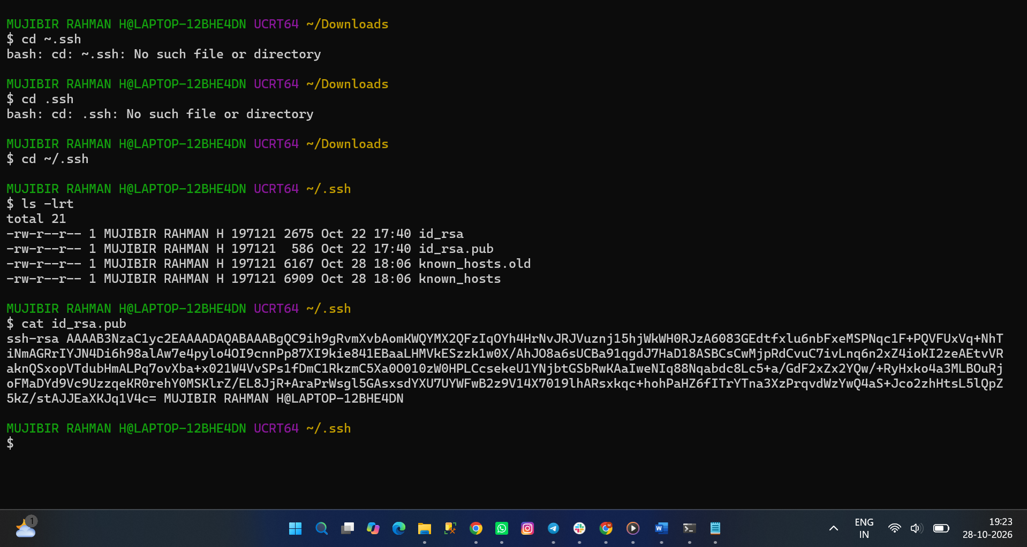
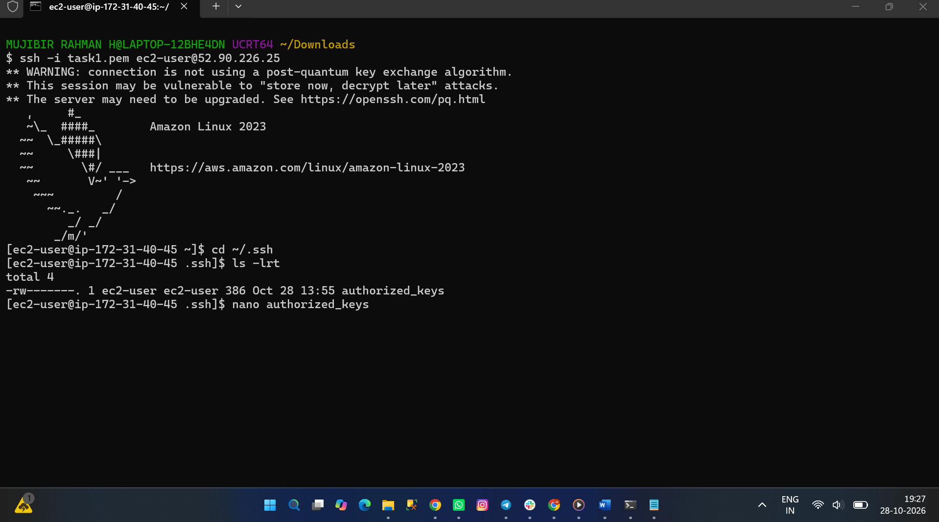
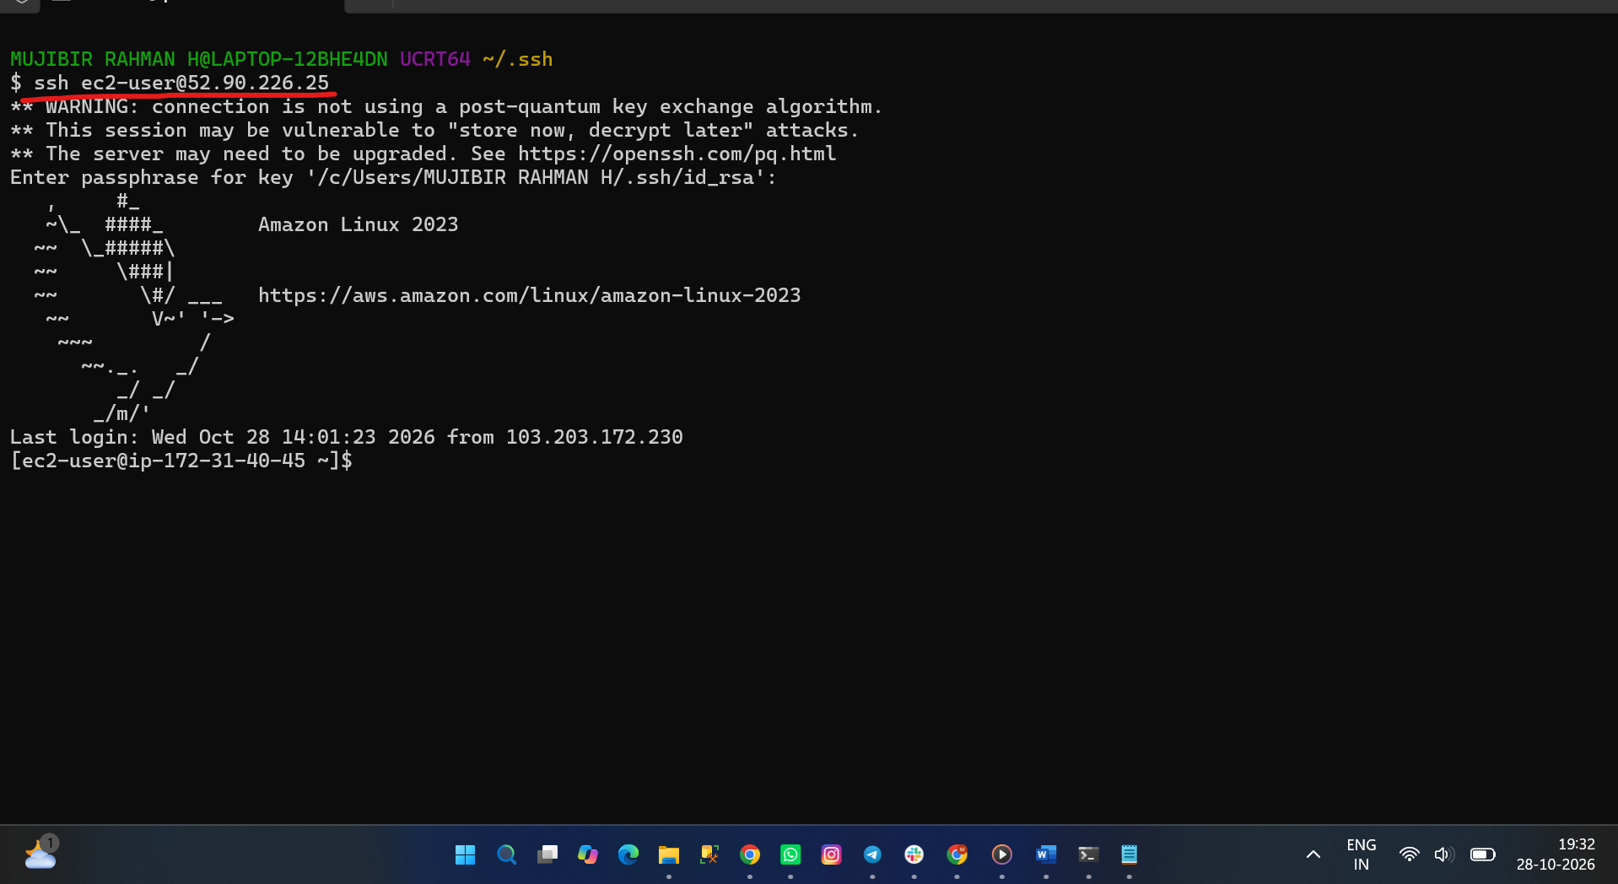
- Launch any EC2 using the spot purchasing option.
While creating the Instance, In advance options I just selected spot instance.
It will create our spot EC2 instance.
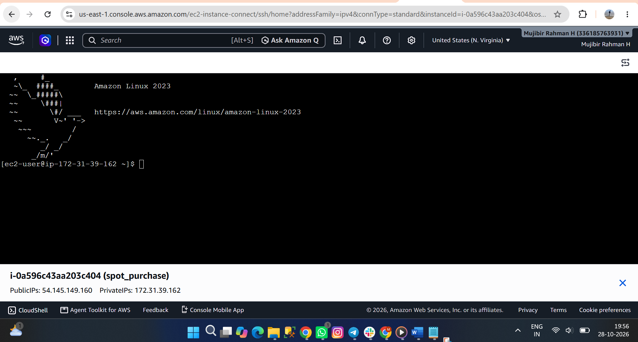
- Enable termination policy on the EC2 created in Task 2.
I am SDM of one of the Banking projects in my organization. I am giving client server access to my team mates for the production deployment.
one of my team mate trying to terminate the instance. That time it will no twork because I enabled this termination production. we can prevent our instance using this option.
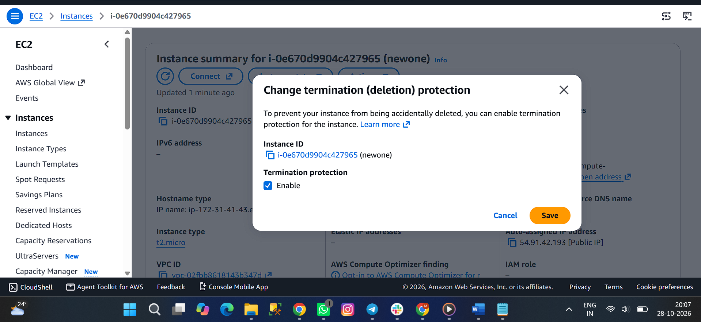
- Launch one EC2 using AWS CLI.
Need to generate Access key and secret key in AWS IAM. I didn’t used IAM user instead of used secret key. But it’s not a good practice to use this.
I just installed AWS CLI in my local and tried to configure my AWS account in my windows in command prompt.
Generated one EC2 instance using aws ec2 run-instances –image-id <AMI ID>
Instance created in EC2, I just renamed.


